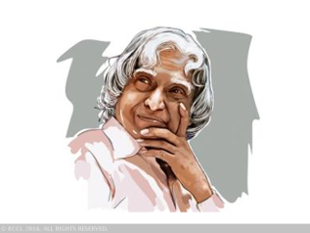
MkW0 ,0ih0ts0 vCnqy dyke th ds fe”ku 2020 dh izsj.kk ls *f”k[kj Hkkjr lsok lfefr* ds ,d NksVs ls iz;kl ds rgr vk;ksftr

vkosnu&i=
vkosnu i= dzekad -------------------------
vH;FkhZ dk uke ----------------------------------------------------------------------------------------------------
firk dk uke ---------------------------------------------------------------------------------------------------------
d{kk ------------------------------ oxZ ¼dyk@foKku@dkelZ@vU;½ -----------------------
fo|ky; dk uke -----------------------------------------------------------------------------------------------------------
----------------------------------------------------------------------------------------------------------------------------------------------
LFkk;h irk -----------------------------------------------------------------------------------------------------------------------
---------------------------------------------------------------------------eksckby ua0---------------------------------------------
mRrhZ.k iwoZ ijh{kk dk fooj.k&
dz0  la0 | ijh{kk dk uke | vuqdzekad | fo|ky; dk uke | izkIrkad@izfr”kr
1- | gkbZ Ldwy
2- | d{kk & 11
eS -------------------------------------------------------- “kiFkiwoZd c;ku djrk gwWa fd esjs }kjk nh x;h mijksDr lwpuk lR; gSa ;fn rF; xyr ik;s tkrs gaS rks esjk vH;FkZu fujLr dj fn;k tk;sA
vH;FkhZ ds gLrk{kj

ijh{kk frfFk & 22 vxLr 2018 izos”k&i= vuqdzekad -------------------------

vH;FkhZ dk uke ----------------------------------------------------------------------------------------------------
firk dk uke ---------------------------------------------------------------------------------------------------------
d{kk ------------------------------ oxZ ¼dyk@foKku@dkelZ@vU;½ -----------------------
fo|ky; dk uke -----------------------------------------------------------------------------------------------------------
ijh{kk dsUnz &
uksV& ijh{kk ds lEcU/k esa fdlh izdkj dh tkudkjh ds fy, fuUu uacjksa ls laidZ dj ldrs gSa&
8009165368] 9125631889] 9956378228] 9935215807] 9208265154]

